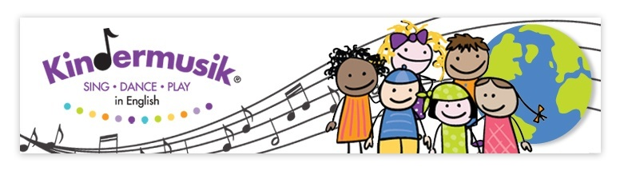
Autumn Semester 2014
Starting week of 25th of August and Finishing week 19th of January 2013
Zoom Buggy —-Village- Newborn to 18 months
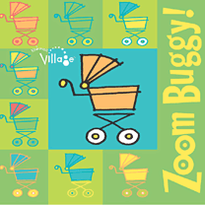 | Swoosh, vroom, and clickety-clack your way through this delightful unit. Babies and adults will dance, sing, and play instruments to the theme of being on the go. Chug around the room to the song “Little Red Caboose,” hold on tightly while “Riding in the Buggy,” and dance your way to “Zoom-e-oh!” Engage in rituals and playful activities such as infant massage, lap bounces, exercise, and quiet time. Home Materials: Colorful board book of different vehicles—Zoom Buggy,Home CD of the songs heard in class, a set of Art Banners for the nursery wall that strengthens visions and promotes early literacy, and a set of shape shakers for music-making at home. The home materials set is offered with an adorable diaper bag that can be used for carrying materials to and from class. Downloadable Materials: Tracks of music heard in class, Home activity book and song texts
9 classes of 45 minutes
- Week of the 25th of August until the week of the 3rd of November

Dream Pillow -Village- Newborn to 18 months
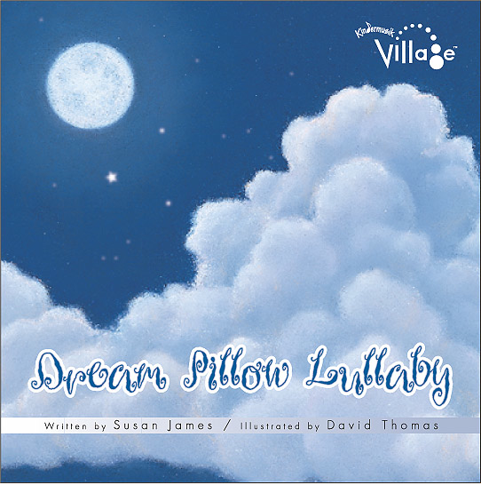 | This title alone brings images of rocking, cuddling, singing, and lulling to sleep. But leading up to sleepy time are many upbeat and playful activities. Babies and Adults will swirl to a dreamy cloud dance “Meet Me Tonight in Dreamland.” They’ll also play baby appropriate instruments to “Aiken Drum,” and “Sarasponda.” Favorite nursery rhymes like “Wee Willie Winkie,” and “Diddle, Diddle, Dumpling,” are sprinkled throughout the classes. It’s easy to weave many of the class songs and activities into your families’ daily routines. Home Materials: A board book that calms and relaxes—Dream Pillow Lullaby, Home CD of the songs heard in class, a set of Art Banners for the nursery wall that strengthens vision and promotes early literacy, and a fish baby shaker for music-making at home. The home materials set is offered with an adorable diaper bag that can be used for carrying materials to and from class. Downloadable Materials: Tracks of music heard in class, Home activity book and song texts
9 classes of 45 minutes
- Week of the 10th of October 2014 until the week of the 18th of January 2014
Prices: Single unit of Zoom Buggy or Dream Pillow (9 Classes) 1 set home materials: €138
Full Semester 265€ (18 classes) – 2 units and 2 sets of home materials
Milk and Cookies - Our Time - 18 months to 3 years
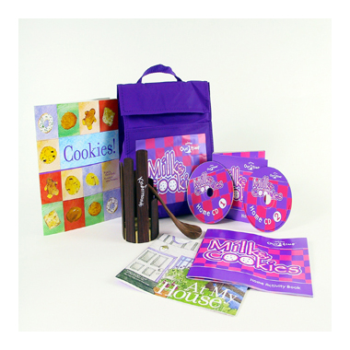 | Make everyday home activities and chores easier and more fun with music! Cook and sing to “The Muffin Man”; dust and clean to the original song “In My House”; get ready to wash clothes to the delightful poem “Washing Machine”. Baking cookies, eating cupcakes, blowing on hot cross buns, wiggling like jelly, going grocery shopping and making tea are all represented in familiar as well as new songs. Move, play, and sing together in developmentally appropriate activities created just for 1 ½ to 3-year-olds. Capture the familiar and new moments of the day and learn how music can impact your toddler. Home Materials: Double CD featuring songs from class; two books—At My House and Cookies, two Home CDs, stir xylophone instrument, and a Home Activity Book—all arriving in a durable lunch bag. Downloadable Materials: Tracks of music heard in class, Home activity book and song texts
18 classes of 45 minutes
Price: 270€

Make Way For Music – Family Time – Mixed Age Group
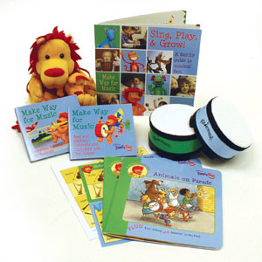 | Families will sing, dance, and move their way through an exploration of several elements of music: beat and rhythm, concepts and contrasts (such as staccato and legato, high and low, the major scale, and arpeggios), the human voice, instrument families, and ensemble. They’ll engage in developmentally appropriate activities that the whole family can enjoy together, including fingerplays, songs, circle dances, story time, and family jam. Home Materials: Two books—Drum Circle and Animals on Parade, two Home CDs, Family Guide, an instrument-matching board game and two fingerdrums. Downloadable Materials: Tracks of music heard in class, Home activity book and song texts
18 classes of 45 minutes
Prices: €270,00 (1 child)
€360,00 (2 children)
€415,00 (3 children)
There is no charge for siblings under 10 months of age!

Hello Weather Let's Play Together -Imagine That- 3 to 5 years
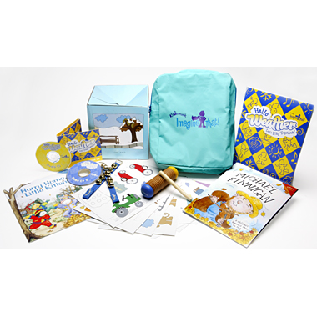 | For Children with some English experience either at home, in the Kita or having lived abroad.  Sunshine, rain, snow, thunderstorms, and more in this imaginative and delightful weather-related musical adventure. Preschoolers create storm sounds with a drum to “Wild Storms,” jump in pretend puddles to “Mud Puddle Jump,” throw pretend snow-balls to “Snowballs,” and sing along to “Colors of the Rainbow.” With weather as our learning theme, preschoolers will explore musical styles that range from Opera to American folk, and become more self-sufficient in a creative musical environment that integrates music, pretend play, storytelling, movement, and more. Home Materials: Two books—Michael Finnigan and Hurry Home, Little Kittens, Hello Weather Play Set, Two Home CD with over 63 recordings of the stories, games, and weather sound effects played in class, 46-page Family Activity Book, and two instruments—ankle bells and rain shaker with scraper. Downloadable Materials: Tracks of music heard in class, Home activity book and song texts
18 classes of 45 minutes (children attend first 30 minutes without parents, last 15 minutes sharing time)
Price: 275€

Semester 1 – Kindermusik for the Young Child – 4,5 to 7 years
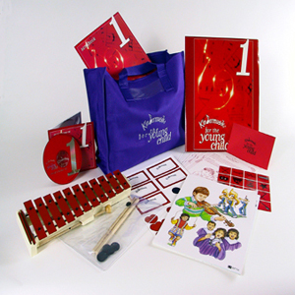 | Everything your child learns later in semesters 2, 3, and 4 begins with this early introduction to singing, reading, and writing music and rhythm. Through dances and games that focus on rhythmic development, we'll learn a keyboard instrument—the glockenspiel—which will be used throughout all the Young Child classes. Your At Home Materials provide the music, instruments, stickers, and activities for a home version of the same playful activities you'll hear about from class, so your child—and you!—can learn where you're most comfortable: at home. Home Materials: Children’s Folder with stickers, games bag, and Music At Home Cards, Family Songbook, Home CD of music from class, glockenspiel, and canvas bag (during first semester).
15 classes of 60 minutes
Prices: €275,00

ABC English and Me – 3 to 6 years
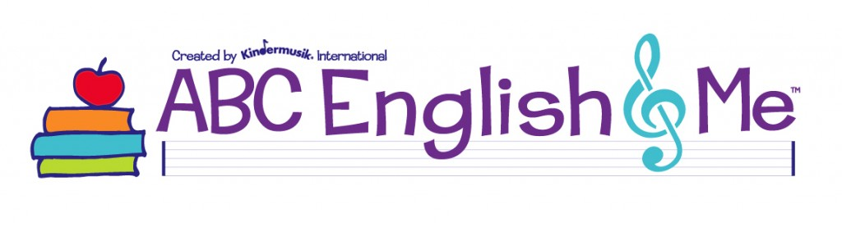 | For Children with no or little prior English experience  ABC English & Me is an exciting mix of music and movement activities proven to help young children learn English while at play!  Combining over thirty years of experience with the most current Early Language Learning methodologies and plenty of fun, the collection of thematic 45-minute lessons makes it easy to engage students ages 3 to 6 and introduce them to English vocabulary and expression in a lively and supportive environment. Using music, which stimulates and enhances language acquisition, and whole-body physical expression, which improves retention, each lesson is effective and enjoyable for all.  Downloadable Materials:  For this course all materials are downloadable. Participants will receive 4 sets of downloadble and interactive materials that support and complete the enriching classroom experience!
18 classes of 45minutes (children attend first 30 minutes without parents, last 15 minutes sharing time)
Prices: €270,00
€360,00 (2 children)
€415,00 (3 children)
There is no charge for siblings under 10 months of age

